**PHASE 5**

**LESSON 2**

**PRACTICE ASSISTED 13**

**SOURCE CODE:**

**Hubconfig.json:**

{

    "port": 4445,

    "newSessionWaitTimeout": -1,

    "servlets" : [],

    "withoutServlets": [],

    "custom": {},

    "capabilityMatcher": "org.openqa.grid.internal.utils.DefaultCapabilityMatcher",

    "throwOnCapabilityNotPresent": true,

    "cleanUpCycle": 5000,

    "role": "hub",

    "debug": false,

    "browserTimeout": 0,

    "timeout": 1800

  }

**Nodeconfig.json:**

{

  "capabilities":

  [

    {

      "browserName": "firefox",

      "maxInstances": 5,

      "seleniumProtocol": "WebDriver"

    },

    {

      "browserName": "chrome",

      "maxInstances": 5,

      "seleniumProtocol": "WebDriver"

    },

    {

      "browserName": "internet explorer",

      "maxInstances": 1,

      "seleniumProtocol": "WebDriver"

    }

  ],

  "proxy": "org.openqa.grid.selenium.proxy.DefaultRemoteProxy",

  "maxSession": 5,

  "port": 5555,

  "register": true,

  "registerCycle": 5000,

  "hub": "http://localhost:4445",

  "nodeStatusCheckTimeout": 5000,

  "nodePolling": 5000,

  "role": "node",

  "unregisterIfStillDownAfter": 60000,

  "downPollingLimit": 2,

  "debug": false,

  "servlets" : [],

  "withoutServlets": [],

  "custom": {}

}

**Start hub using Cmd:**

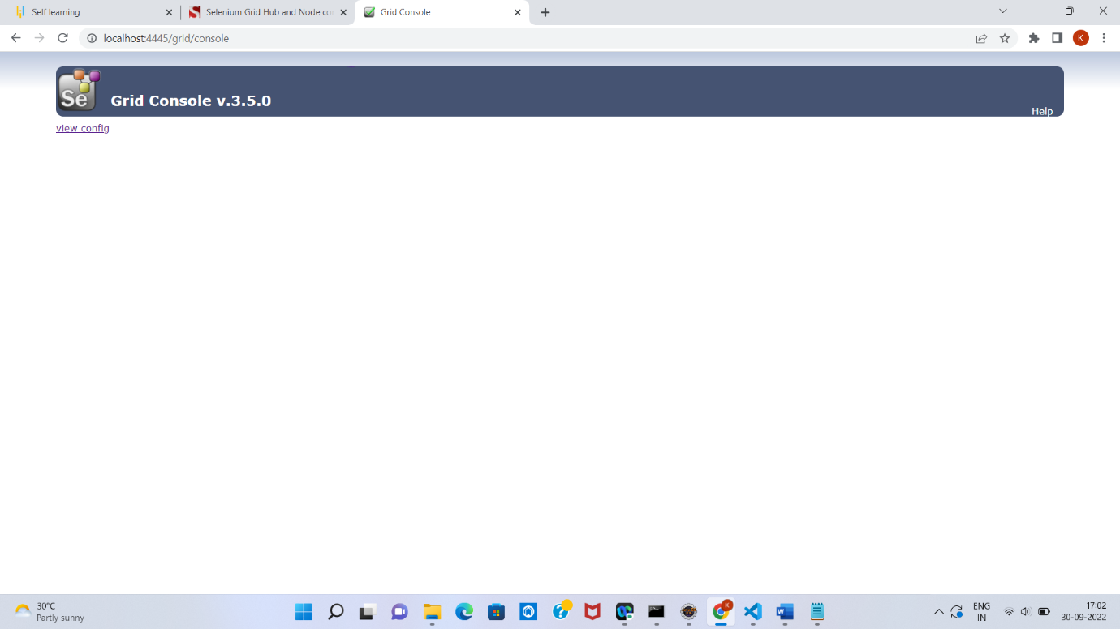

**Start NODE using Cmd:**

